MADOLCHE ARTIFACT - From theory to practice
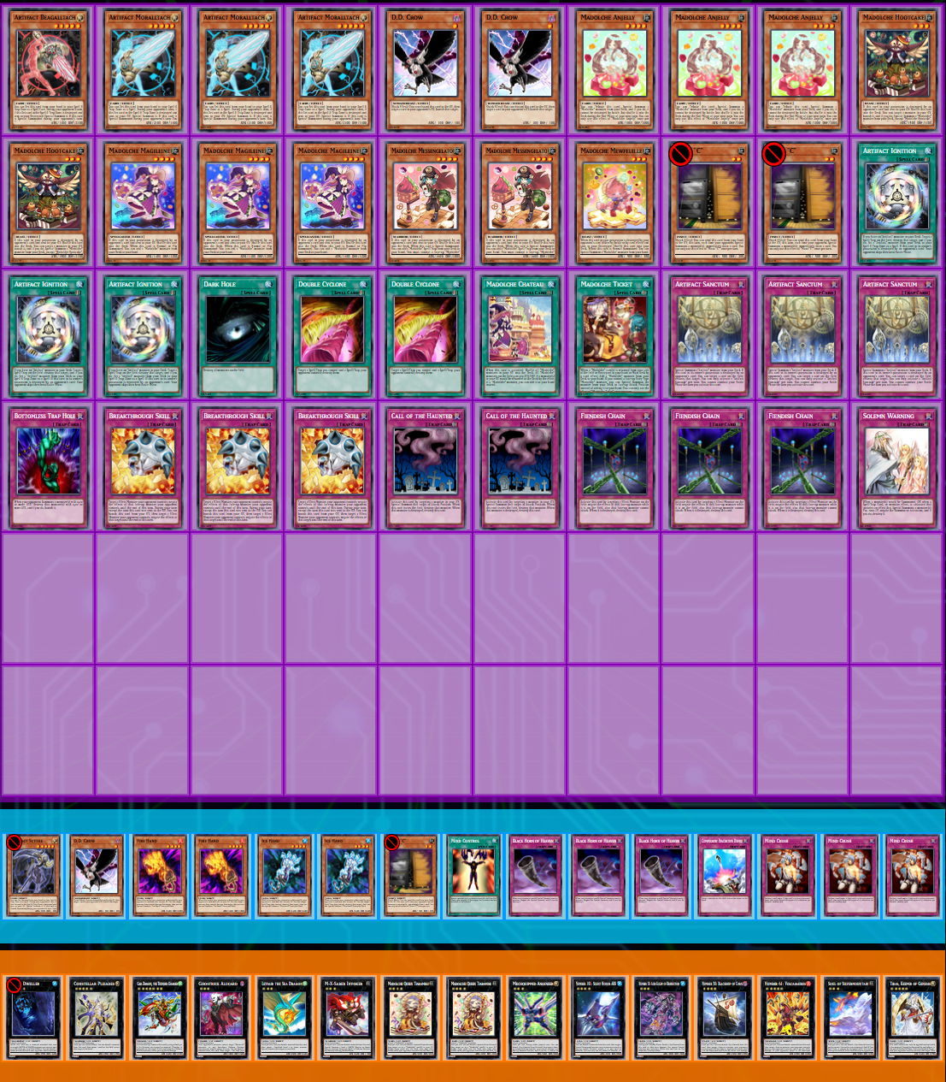
As many people have pointed out, I in fact DID NOT invent the »Madolche Artifact« deck. It was tried and played before. However, I was not aware of those past lists and attempts, so that is why my »Madolche Artifact Manifesto« does not reference any of the existing lists and ideas. The list we built (by »we« I mean me, Brandis and Benis) on the basis of the theory presented in the article is also not influenced by any existing lists.
Having said that, I want to quickly go through what I have been doing since posting the manifesto. Naturally, I have been building the deck and trying it out. After settling on the main card choices, and I will write more about that later on, I have been playing the seasonal HAT ladder and registered to 3 tourneys. The results (at the time of writing) are as follows:
- HAT ladder: 31-7 | 1st place (42 players),
- MM54: 3-1 | dropped (funny story, 79 players),
- SESB22: 3-1 | 2nd place (17 players),
- PP24: 7-0 | 1st place (15 players).
Unfortunately the results themselves (especially such small amount of data) will never be able to show which variant of Madolche is better, that is why I prefer to talk and think on the basis of theory. But in card games, as in martial arts, the theory has to be stress tested in real competition and be therefore validated or abandoned. The results so far are encouraging, but they do not constitute a proof. What they do show is that the theory can be translated into a competitive deck.
Now, what can be said regarding the common criticism that states something along the lines of the following:
»Any deck with a sufficiently large Artifact package is just an Artifact deck, you are just playing unoptimised HAT. Congratulations to doing well with HAT in HAT format!«
In the light of Artifact slop piles that sometimes do well, especially recently, this criticism is valid and must be addressed. But that is precisely what the manifesto was about. There is nothing more that I want to add to what has already been written. In short, the Artifacts in this deck help solve some of its main general problems and increase the winrate in common and critical matchups - they are not just thrown in with no thought and no reason, just for the sake of playing Artifacts in a deck that may or may not benefit from them.
Let us talk about the decklist. When you actually try to build the deck just on the basis of the manifesto, you quickly find that the space is really tight. Naturally, the cards that you want to play initially are:
- Madolche engine,
- Artifact engine,
- Extended Artifact support cards such as Double Cyclone and Call of the Haunted,
- Soul Charge,
- Staples (Dark Hole, Book of Moon, CED, BTH. Warning, TT),
- Instant Fusion (bridge extender between Artifact and Madolche engines, otherwise a staple in any Madolche deck),
- Hand traps,
- Wiretaps (good for shuffling back BTS especially in the Artifact variant, as well as helping with usual problems of Madolche's Normal Summon being disrupted, or critical XYZ play being disrupted).
You cannot play all of these in a 40 card deck. Let us first talk about the cards that I did not include:
- I tried to make Soul Charge work in the deck, but have not yet found a way to do it. Riftwa's deck is designed for Soul Charge, but those ideas cannot be translated to our variant. Soul Charge does not make the cut here – the bricking, the slowness and unreliability due to the lack of support are too apparent.
- Wiretap was initially thought of as a 3-of staple. It is common knowledge that Wiretap is not very good into every matchup, and at some point I decided to move it to side and to side it only vs HAT. What happened was that I was winning Game 1's vs HAT regardless. And post side we improve the deck with the really important anti-HAT cards and we find there is no space to add Wiretaps in. So Wiretap is out.
- Instant Fusion is probably the strangest cut in my list. I really wanted to play Call of the Haunted, but there was simply no space to play both extenders (Call and Fusion) without cutting defenses. And cutting defenses has proved to be a bad idea during testing. By cutting Fusion I was also able to increase my Extra Deck variety as well, which won me games more than once. When I made the cut, it was just for testing, but I kept winning without it. Additionally, COTH itself becomes and behaves like an Instant Fusion if any Madolches hit Graveyard.
- No Torrential Tribute is due to the fact that out of all defensive cards I play, Torrential is the only one that would not preserve my monsters. This is very critical in Madolche, so it does not make the cut, although Brandis can tell you that this really pains me. But I think it is correct not to play it.
That about covers all of the most important not-played-cards. It is time to finally address the decklist that was actually played.
- Madolche engine: the minimal engine is staple, the only difference I decided last minute on was cutting Torrential to add the second Gelato. The reason I did this was mostly due to Brandis convincing me to do it, and his argument is sound. Drawing a Gelato is not so problematic, having none in deck is. Assuming a 40-card deck and a 6-card opening hand, playing one Gelato means drawing it 15% of the time. With two copies, the probability of drawing both falls to approximately 1.9%, while the probability of drawing at least one rises to approximately 28.1%. So, by playing two Gelatos, we decrease the chance to having none in deck from 15% (if we play just 1 and draw it) to 1.9% (if we play play 2 and draw both). That is 13.1% increase of a metric that we actually care about. Of course, we must also accept that we will draw 1 Gelato more often. Do with the numbers what you will. I have simply decided to go with the 2, although 1 can work just fine.
- Artifact engine was cut from initial 5 Artifacts to 4 with 1 Scythe in side. This deck does not need 5 Artifact nearly as often as slower HAT decks, games tend to not be so grindy. I side Scythe vs decks where it really matters. You could also do 2 Moral, 1 Scythe main.
- 2 Double Cyclones are absolutely necessary, as per manifesto. We need the backrow removal for Madolche part of the deck as well.
- For handtraps I decided on 2 Crow 2 Maxx. It is not clear to me that this particular ratio is better than 3 Crows 2 Maxx or 3 Crows 1 Maxx. I have decided at one point that I will never build a deck which has 3 dead or 3 really bad cards vs any of the top 5 decks. This »deck building filter« has automatically settled me on 2 Crow 2 Maxx, since Crow is bad vs Geargia, and Maxx is bad vs Bujin, Spellbook, and is not even very good vs HAT...
- For the defense of choice, we went with 3 BTS and 3 Fiendish (as opposed to Book, CED, TT...) because these work really well vs opposing Artifacts and also range from »meh« at worst to »good« vs other matchups. Fiendish also stops attacking, which is critical with Madolches.
- Solemn and BTH are both staples which also support the above point. Notably, BTH is not good vs Artifacts, but it is really strong otherwise so it has been kept.
- Dark Hole is the mass removal I kept, although Brandis and Benis wanted to cut it. It is not a synergistic card in any way, but it just does things that only Dark Hole does. An article could be written just on Dark Hole, but I do not want to get into it here.
For the Side Deck, there is nothing notable there, except for Hands. We side Hands vs HAT, since that is where they excel in. There is not a more impactful handful of cards that you can side vs HAT than Hands.
For the Extra Deck, the most notable thing is the flexibility of the slots that are gained, since we are not playing Instant Fusion. Due to that, Exciton can also be cut, since he is never summoned without the help of Instant Fusion. Pleiades and Tiras are the mandatory R5s, followed by Volca and Gaia. Invoker is always played if you are on 2 Gelatos, since it allows some otherwise impossible lines. Dweller and 2 Ships are the best R4s to play. Alucard is for Geargia almost exclusively, Silvermountain is better generally.
What is next? I would like to see more people experiment with and play Madolche variants, especially Madolche Artifacts (even though the potential popularity of mirror match would probably force some (very unwelcome) changes...). Try the cards that I did not run and see if I missed something. Try Instant Fusion over COTH, or try both. Try to make Soul Charge work. As for me, I am not bored of Madolche Artifact just yet, and there is also #1 spot on ladder needing of being defended...

Until next time,
Wisk.

P.S. Why was I disqualified from MM? It turns out that RetroBot automatically »drops« a player if the player leaves the Discord server in which the tournament is hosted. So, don't leave a server while in a tournament.

